Email –

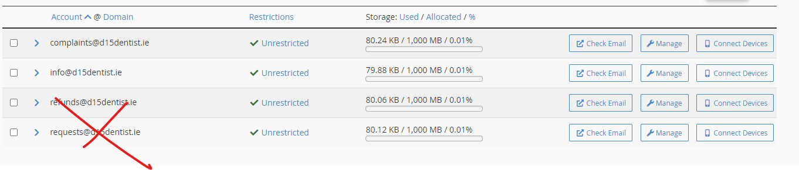

[bills@d15denstist.ie](mailto:bills@d15denstist.ie)

Observation and genral points.

1. Book an appointment button
2. Referral page - <https://www.mintclinic.ie/referrals/>

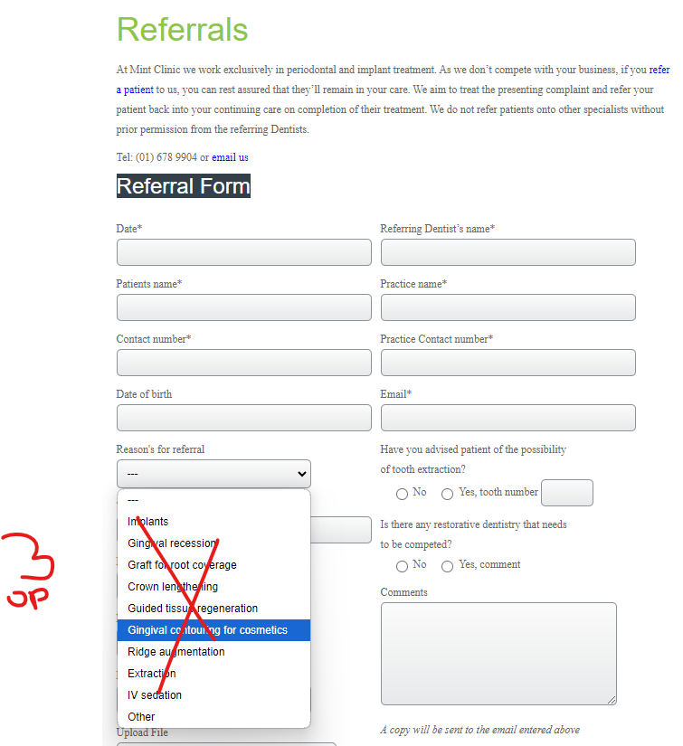

1. Orthodontics
2. TMD
3. Sleep apnoea
4. Headache and migraine

- Overall the design looks modern and fresh. Good pick.  
- Nice pictures selected for the home page. It creates a high-quality image of the clinic  
- Great that you made a sticky top line with "Book an appointment" well-visible

----- book appointment in side

Address update

Phone no update

GP button.

Remove play video – by gp button.

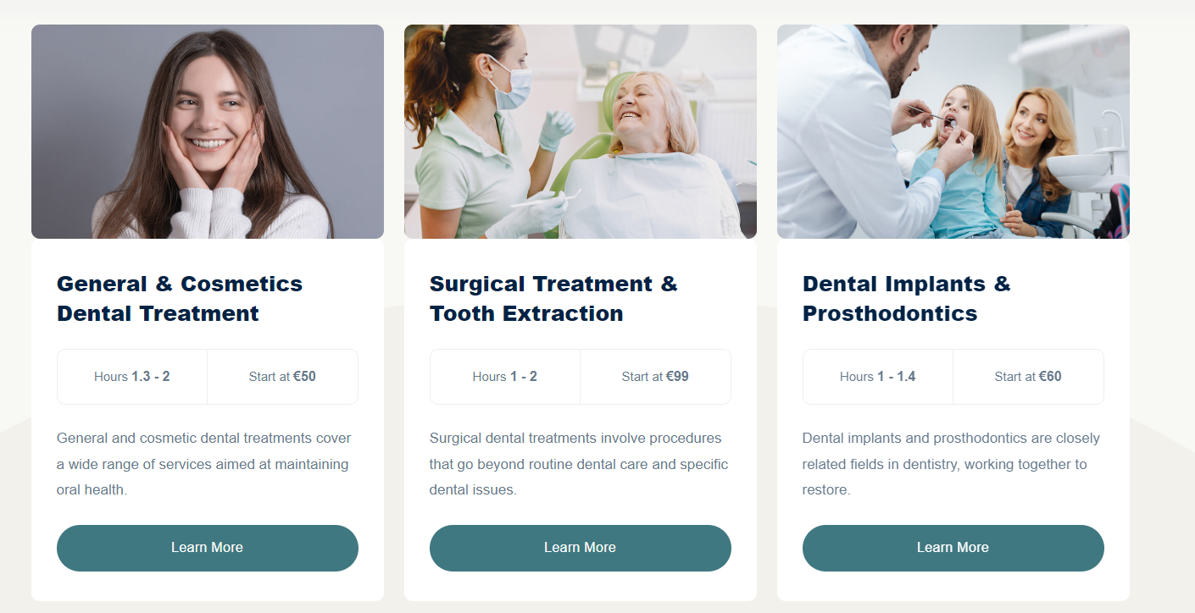

Section are

1. General dentistry
2. Composite bonding and Cosmetic Treatment
3. Dental Implats and Prosthodontics

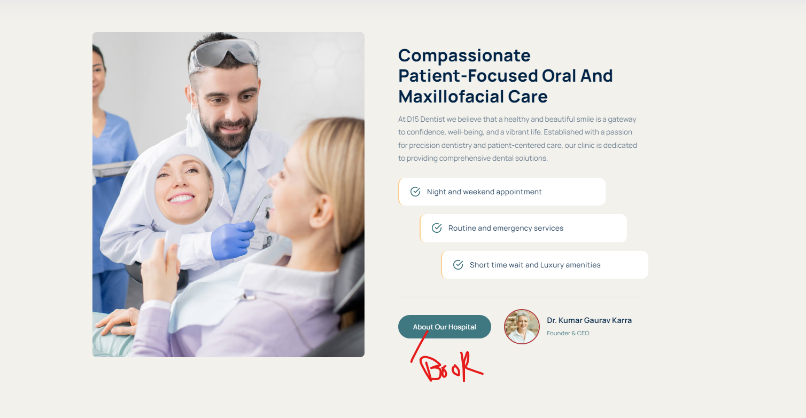

Update text –

Heading – Orofacial Pain, TMDs and Sleep apnoea

Disorders of the temporomandibular joint (TMJ) disorders (jaw joint disorders)  
Muscular pain & Stiffness in the jaw & face  
Clicking and / or locking in the jaw joint  
Neurovascular pain affecting the face  
Trigeminal & other Facial Neuralgias (Nerve Pain)  
Neuropathic (Nerve) Pain following injury to the nerve

Remove

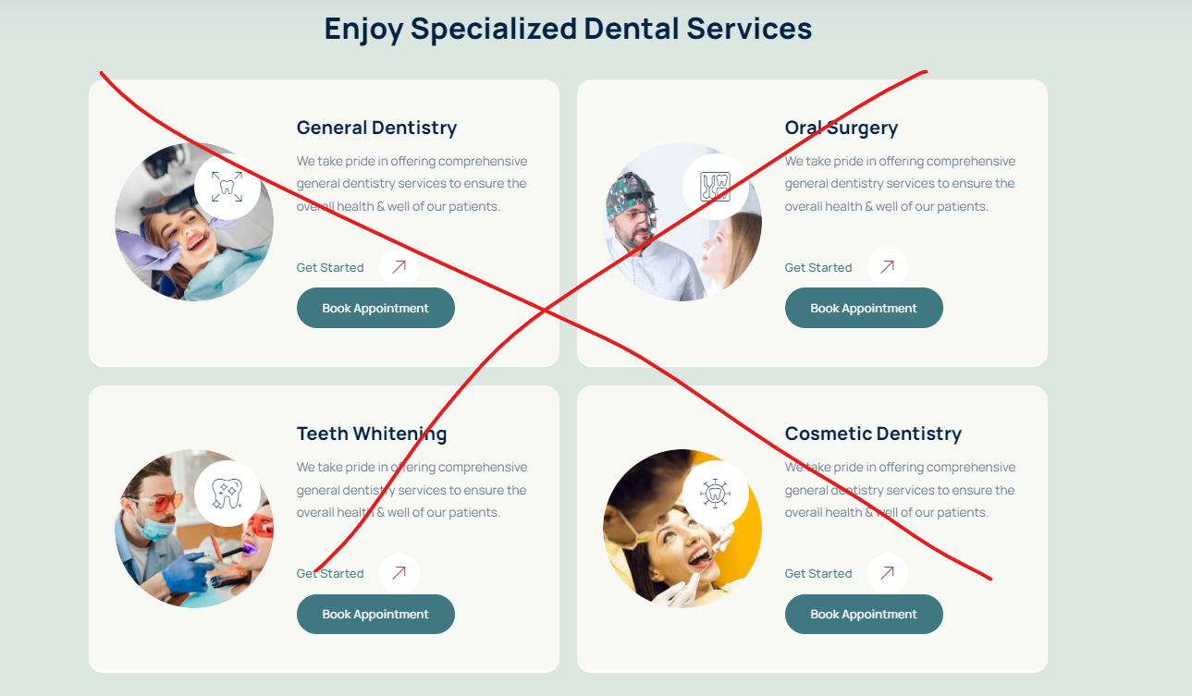

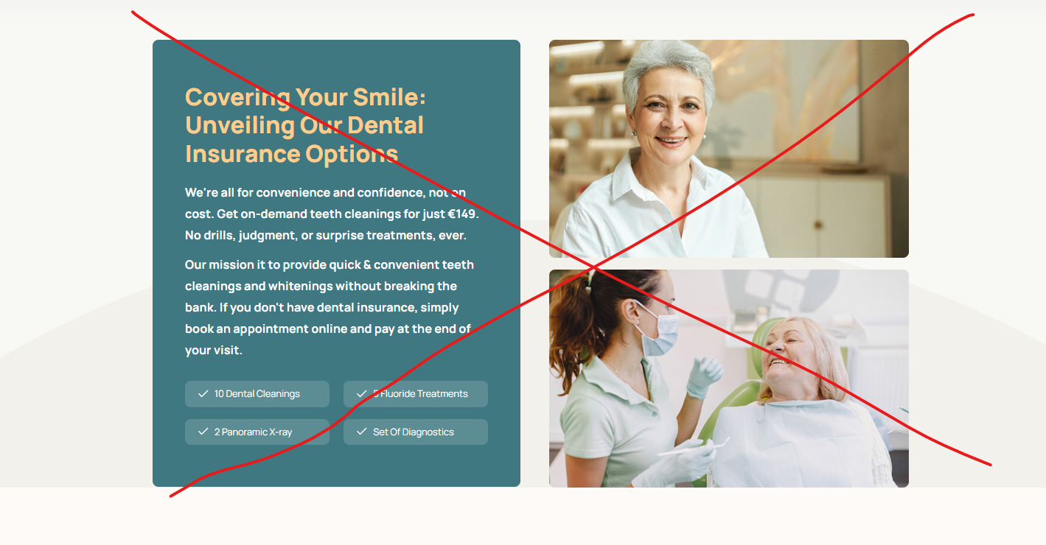

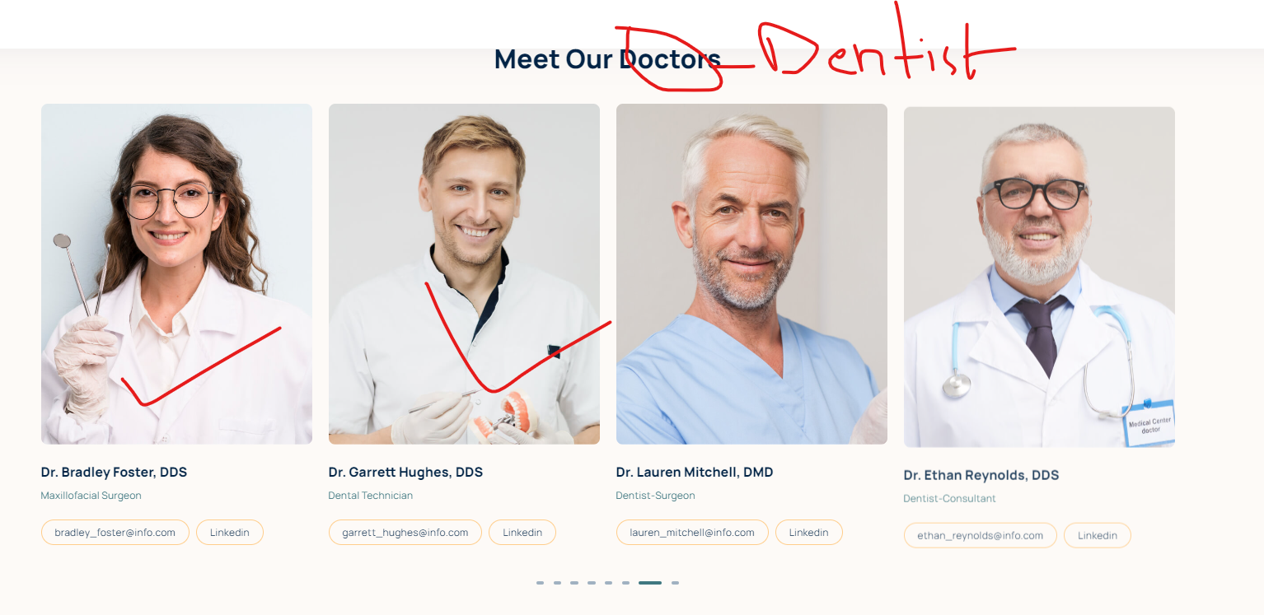

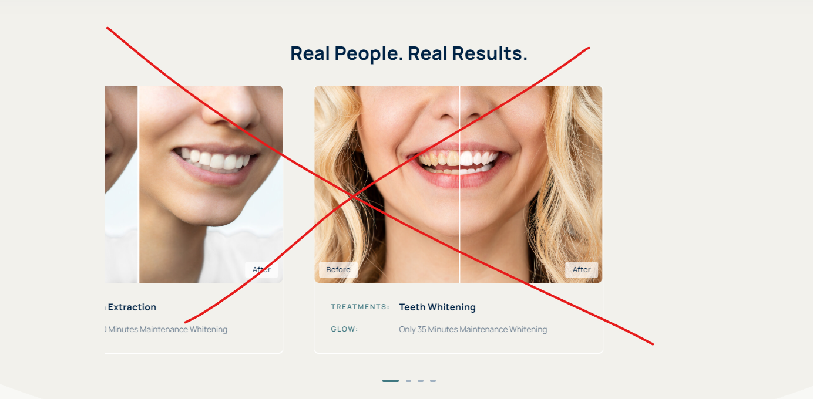

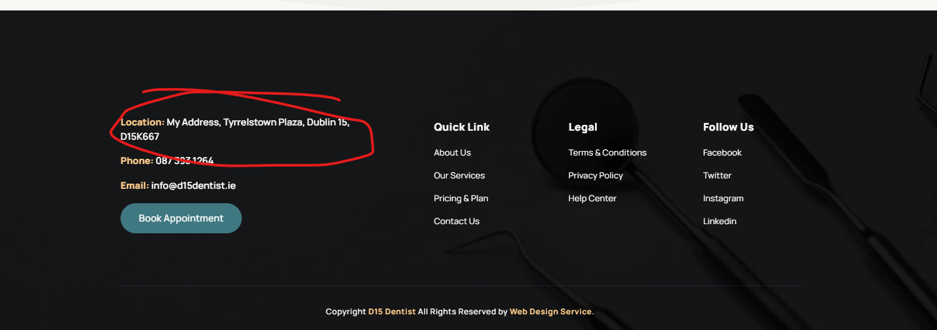

Phone no and address change.

2 Dentists and swap doctor with Dentists

**Page About us**

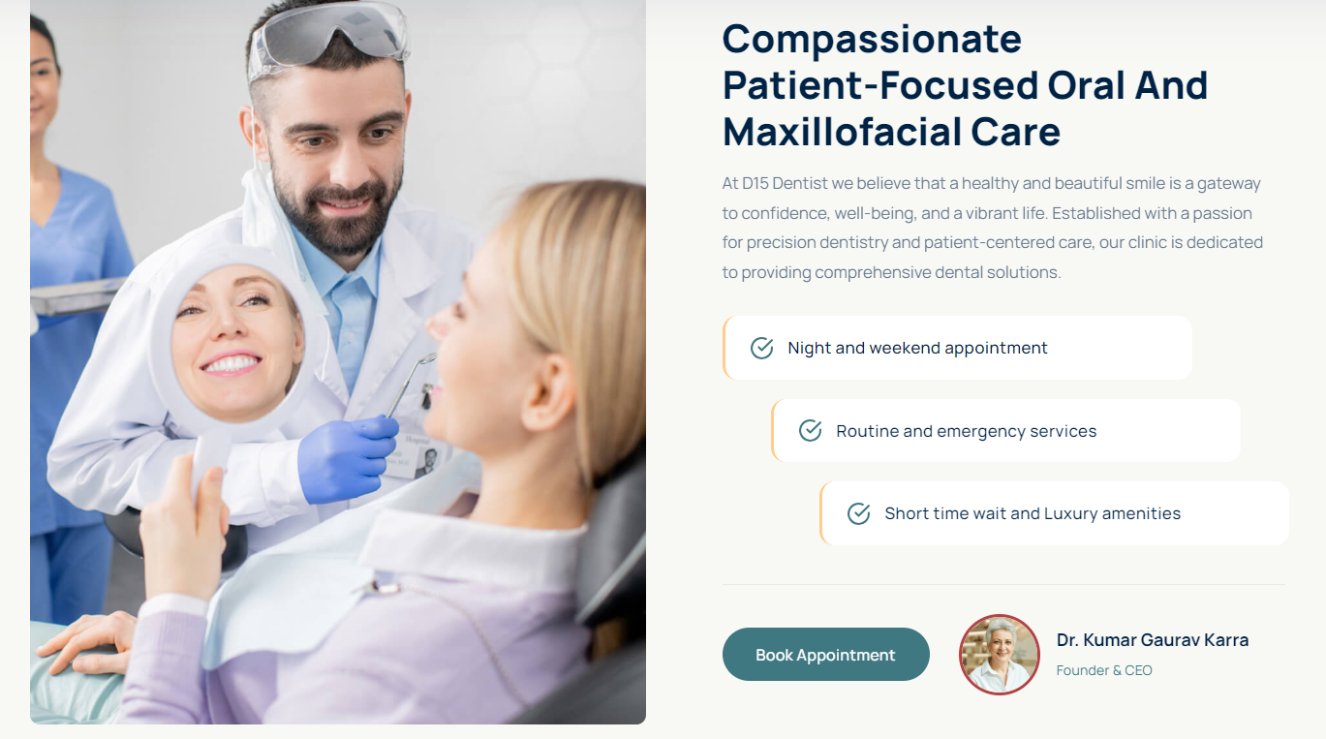

Heading and text

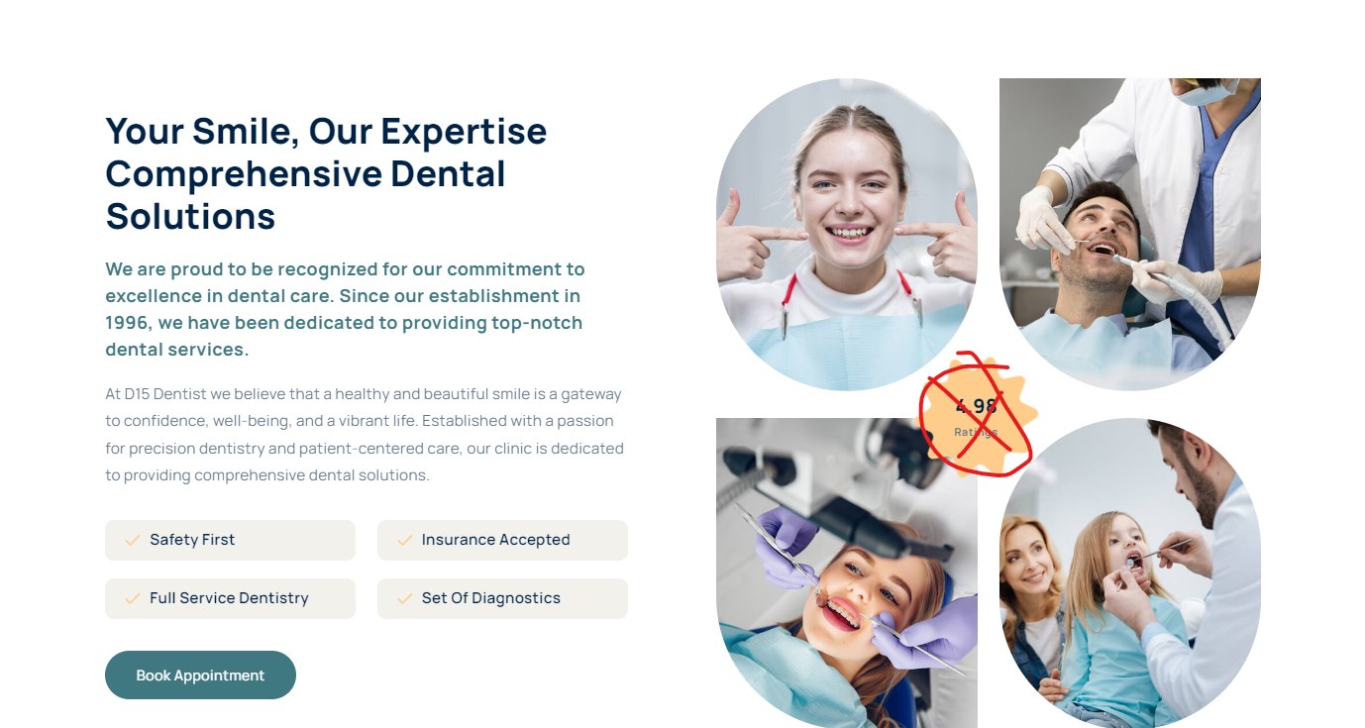

Heading text

Price List

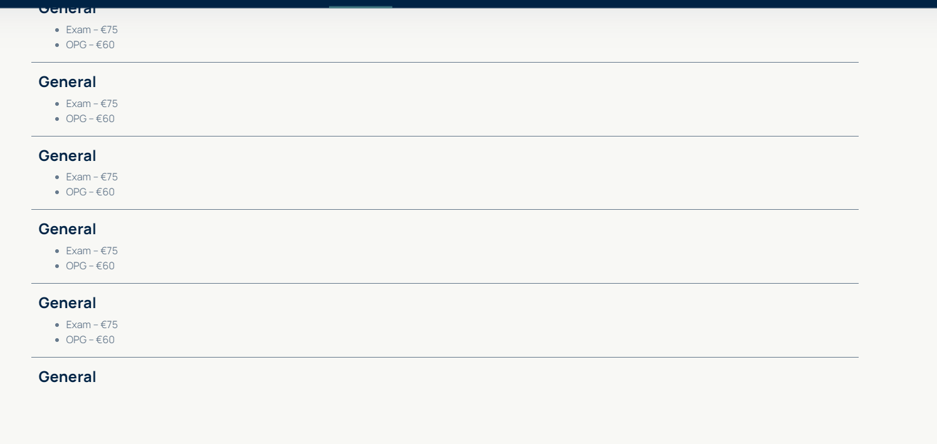

Update the price list

Services –

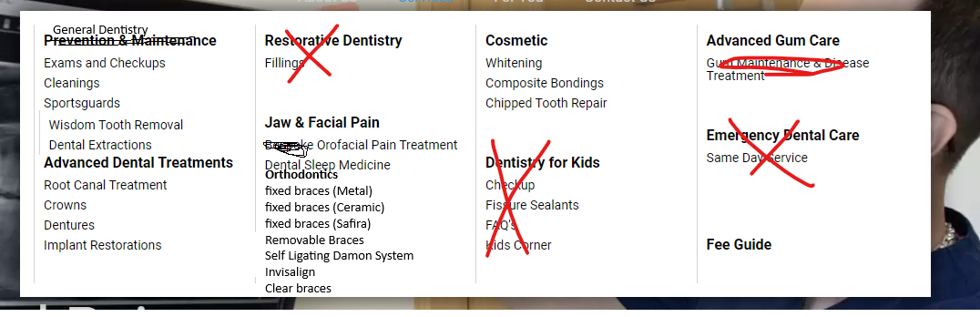

Menu - <https://roscamdental.ie/services/jaw-facial-pain/>

<https://www.enhance-dental.ie/price/>

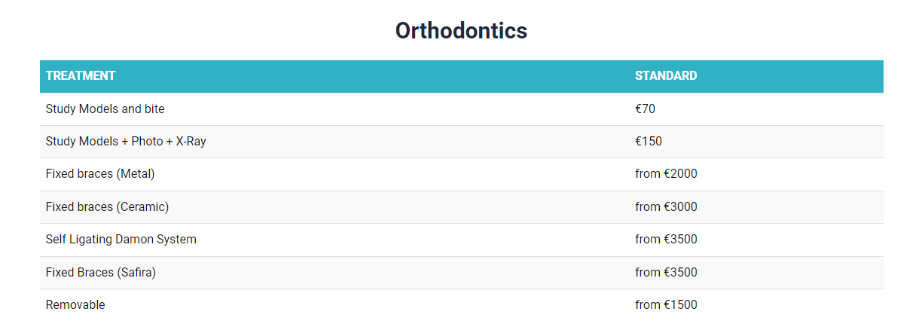

**Contact us**

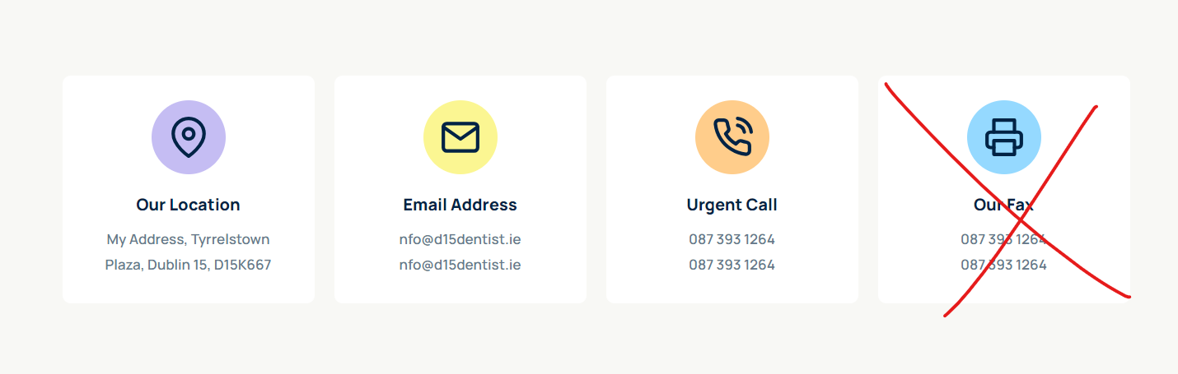

Email address swap by – Contact us (email and phone no)

Dentist profile

Sara and Dr Shaab

- Great that you have Before/after on the homepage. It's good also to have an additional before/after page on the website as well as add before/after to landing pages of each procedure where it fits, e.g. implants, bridges, bonding  
- On mobile the top line with contact details takes too much screen space. It should be reduced, ideally to one line.  
- If there is a possibility, add a "Make an appointment" button on the sticky top line on the mobile as well  
- On the address tab in the contact details page, add the "See location" button to the Google Maps below. Many people will not get to the map, as it's at the bottom of the page. Especially when browsing on mobile.  
- For the "Book an Appointment" page, delete fields: Preferred doctor (people usually don't know the names of doctors when it's a new clinic or a new patient.)  
- Add a review block on the home page and on every service page.

Doctor shaab

[**Dr. Kumar Karra**](https://www.smiles.ie/clinic/smiles-dental-dublin-15-blanchardstown/meet-the-team/)

Dr. Kumar Karra graduated from India in 2002. He spent more than 10 years working in his native country as a general dentist before moving to Ireland, where he started practicing dentistry in 2015. Through the years, Dr. Kumar has upskilled by doing many courses, including composite bonding, Endodontics, restorative dentistry and implants. He has done Dip PCD, MFD and MGDS from the Royal College of Surgeons, Ireland. He is almost finishing a Master’s Degree in OroFacial Pain with Prestigious University of Southern California, U.S.A. He provides treatment relating to TMD’s, Nuropathic pains, headaches and Sleep Apnoea. He is skilled in dealing with nervous patients.

Dr.Sara Flanagan  
  
With over 17 years of experience in transforming smiles, Dr Sara Flanagan is a highly skilled and compassionate orthodontist dedicated to providing personalised care for each patient. She has honed her expertise in a wide range of orthodontic treatments, including traditional braces, clear aligners, and advanced corrective procedures.  
Dr. Flanagan is committed to staying at the forefront of orthodontic innovation, regularly attending continuing educational courses and incorporating the latest techniques and technologies into her practice. Her patient-centered approach ensures that each treatment plan is explored to meet unique needs and goals of her patients, helping them achieve beautiful, healthy smiles.  
Beyond her technical skills, Dr. Flanagan is known for her warm and approachable manner, making every patient feel comfortable and confident throughout their orthodontic journey. Whether treating children, teens or adults, Dr.Flanagan strives to create a positive experience and lasting results.  
When she is not in the office, Dr.Flanagan enjoys staying active in the community, volunteering her time to promote dental health education and participating in local events. Her dedication to excellence in orthodontic care and her genuine passion for helping others make Dr.Flanagan a trusted and respected professional in the field.